# **The Japanese press release can be viewed from this link.**

https://prtimes.jp/main/html/searchrlp/company_id/134977

# **For those who wish to read it in English, please translate the page or refer to the document below.**

# 

# 

# 

# 

# 

# 

# 

# **Spakona collaborates with Juroku Bank**

## **Supporting the introduction of AI technology to promote digital transformation for companies in the Tokai region**

[Spakona Inc.](https://prtimes.jp/main/html/searchrlp/company_id/134977)

December 12, 2024 11:00 AM

7

Spakona Inc. (Head office: Shibuya-ku, Tokyo, CEO: Taro Kawasaki) signed a business matching agreement with Juroku Bank Ltd. (Head office: Gifu City, Gifu Prefecture, President and CEO: Akihide Ishiguro) on November 27, 2024. The two companies will support the promotion of digital transformation by promoting the introduction of AI technology to solve the productivity improvement challenges faced by companies in the Tokai region.

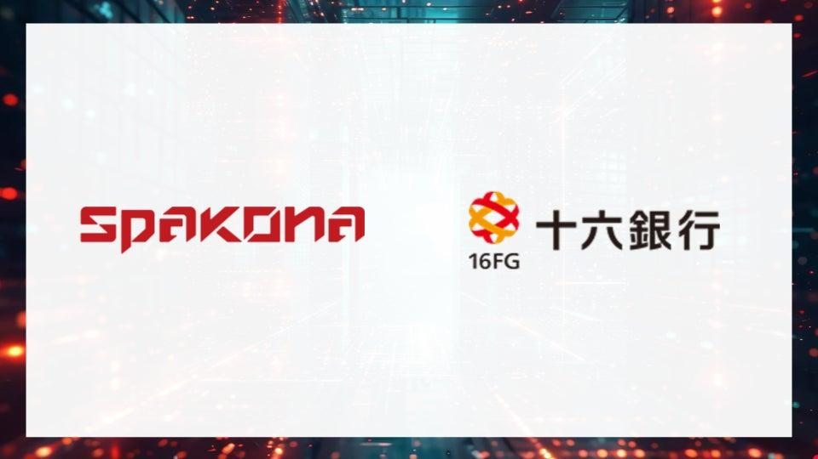

## **◾️Background to the conclusion of the business matching agreement**

Japanese companies are faced with the need to solve a wide range of issues, including rising labor costs due to a labor shortage, the need to improve business efficiency, and the introduction of technology to improve safety. Companies in the Tokai region are no exception, and while expectations for improving productivity and promoting digital transformation are rising, they currently face difficulties in grasping the ever-evolving IT technologies and utilizing them effectively to address their own issues.

In light of this situation, we have concluded a business matching agreement with Juroku Bank to provide cutting-edge AI technology to companies in the Tokai region. Juroku Bank will introduce us to companies in the Tokai region that have issues, and we will provide them with solutions that utilize cutting-edge AI technology.

## **◾️Details of specific initiatives**

We provide a comprehensive range of consulting, development, and maintenance services for cutting-edge AI technology. We have a wide range of AI technologies, including image processing, 3D processing, and mathematical optimization, and can select the AI ​​technology that will be most effective for your business challenges. By proposing the AI ​​technology that will be most effective for your challenges, we support the digital transformation of companies in the Tokai region.

=======================================================================

Spakona is stepping up its recruitment of engineers

We are looking for engineers who will be responsible for developing AI services and systems for enterprises. For details on the positions, please see the link below.

<https://www.wantedly.com/companies/company_8904649/projects>

=======================================================================

## **◾️Spakona Inc. Company Profile**

As an AI company founded by the University of Tokyo, we provide consulting, development, and maintenance of cutting-edge AI technology. With a wide range of AI technologies, including image processing, 3D processing, and mathematical optimization, we can select the AI ​​technology that is most effective for your business's challenges. We also have a strong track record of collaboration with major companies, including Toyota Motor Corporation and Art Moving Center Co., Ltd.

Company name: Spakona Inc.

Address: 6F Higashi SS Building, 2-17-11 Higashi, Shibuya-ku, Tokyo

Representative: Taro Kawasaki, President and CEO

Founded: August 7, 2020

Business description: Planning, development and operation of corporate software services

Company website: <https://spakona.co.jp/>

Wantedly: <https://www.wantedly.com/companies/company_8904649>

# **Spakona forms capital and business alliance with Ai Holdings**

## **Uses AI to improve business efficiency and strengthen competitiveness**

[Spakona Inc.](https://prtimes.jp/main/html/searchrlp/company_id/134977)

July 1, 2024 15:00

5

Spakona Inc. (Head office: Shibuya-ku, Tokyo; CEO: Taro Kawasaki) is pleased to announce that it has entered into a capital and business alliance with Ai Holdings Co., Ltd. (Head office: Chuo-ku, Tokyo; Chairman and CEO: Hideyoshi Sasaki).



◾️Background to the capital and business alliance

Spakona is an AI development company founded in 2020 with the mission of "optimally designing the world." With cutting-edge machine learning technologies and system development capabilities, such as deep learning (deep learning) for generative AI, image processing, 3D shape processing, and voice processing, the company provides AI-based systems to customers in a variety of industries, including retail, finance, chemical manufacturers, and the transportation industry. In particular, for solutions for the manufacturing industry, including major automobile manufacturers, the company is focusing on the deployment of automated systems that utilize image processing and 3D shape processing, improving the efficiency and quality of the manufacturing process, while also improving productivity at the manufacturing site. In addition, the company is focusing on automating back-office operations using generative AI, and is helping to improve the operational efficiency of the entire company by efficiently and accurately processing tasks that were previously performed manually.

Meanwhile, Ai Holdings Co., Ltd. is engaged in businesses such as security equipment, information equipment, card equipment, other office equipment, design, and decarbonization systems. Recent advances in AI (artificial intelligence) technology have been remarkable, and in the surveillance camera industry of the security equipment business, AI technology is beginning to be used for "visualization" and "marketing" in addition to traditional crime prevention applications.

Through this capital and business alliance, we will utilize our strengths in image processing AI, VLM (Vision Language Model) and other generative AI and automation technologies to improve the productivity of the entire Ai Holdings Group and strengthen the competitiveness of our products. In addition, we will realize business value innovation to build a sustainable social environment, aiming to address Japan's social issues of a declining working population, aging population problems, and DX promotion.

◾️Comment from the representative

Ai Holdings Co., Ltd. Chairman and Representative Director, Hideyoshi Sasaki

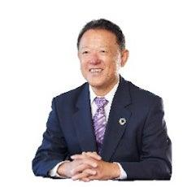

"We are very pleased to have entered into a capital and business alliance with Spakona in the domestic AI market, which is expected to continue to expand due to the recent growing need for automation and labor-saving, the spread of 5G, and other factors. By linking this with the diverse services offered by our group, we will contribute to promoting digital transformation and resolving issues for our customers and partner companies."

Taro Kawasaki, CEO of Spakona Inc.



Generative AI technology continues to evolve at an explosive pace every day, and its application to business and solutions to the issues that need to be addressed will be extremely important themes in the coming era. We have been engaged in AI consulting and technology implementation support business since 2020, and have increased our knowledge by collaborating with major automobile manufacturers and academia. Through this capital and business alliance, we aim to not only improve the productivity of the entire Ai Holdings Group, but also to improve the competitiveness of our main products, such as security equipment.

◾️Spakona Inc. Company Profile

We have independently developed and possess cutting-edge research-based technologies for object recognition in images and videos, human facial expression analysis, customer needs analysis using natural language processing (NLP), a wide variety of big data analysis technologies, and RPA, a technology that improves productivity by streamlining operations. We provide consulting services related to cutting-edge AI technologies in general, and services to introduce our own AI technologies with the aim of building new businesses.

Company name: Spakona Inc.

Address: 6F Higashi SS Building, 2-17-11 Higashi, Shibuya-ku, Tokyo

Representative: Taro Kawasaki, President and CEO

Founded: August 7, 2020

Business description: Planning, development and operation of corporate software services

Company website: <https://spakona.co.jp/>

# **Notice of company name change from Daedalus Inc. to "Spakona Inc."**

[Spakona Inc.](https://prtimes.jp/main/html/searchrlp/company_id/134977)

July 1, 2024 09:00

8

Daedalus Inc. (Headquarters: Shibuya-ku, Tokyo, CEO: Taro Kawasaki) is pleased to announce that on July 1, 2024, the company will change its name to Spakona Inc. and adopt a new mission: "Design the World Optimally."



◾️Overview of company name and mission change

Since our founding on August 7, 2020, we have aimed to create more creative time for all companies and people by applying information technology and AI-related technologies that are used in a wide range of fields, from the automation of repetitive tasks typified by RPA to advanced prediction of future information using AI, in the business world. About four years have passed since our founding, and as AI technology is evolving at an explosive pace, we have reexamined our role in a broader sense and have decided to change our company name and mission.

◾️New company name and mission

Company name: Spakona Inc.

* The name comes from the prophet "spákona" in Norse mythology. A spákona is someone who foresees the future and contributes to people through prophecy and fortune-telling. We named ourselves "Spakona Inc." with the desire to contribute to our clients by foreseeing the future and providing optimal solutions.

Mission: Design the World Optimally

* We consider the concept of "optimal" to be the state in which all resources are used most efficiently in society, and we believe that the social implementation of systems with AI (artificial intelligence) technology at their core is essential. With the change of our company name and mission, we have renewed our spirit and will provide value to society with the aim of realizing the "optimal" state.

◾️Spakona Inc. Company Profile

We have independently developed and possess cutting-edge research-based technologies for object recognition in images and videos, human facial expression analysis, customer needs analysis using natural language processing (NLP), a wide variety of big data analysis technologies, and RPA, a technology that improves productivity by streamlining operations. We provide consulting services related to cutting-edge AI technologies in general, and services to introduce our own AI technologies with the aim of building new businesses.

Company name: Spakona Inc.

Address: 6F Higashi SS Building, 2-17-11 Higashi, Shibuya-ku, Tokyo

Representative: Taro Kawasaki, President and CEO

Founded: August 7, 2020

Business description: Planning, development and operation of corporate software services

Company website: <https://spakona.co.jp/>